Spending Trend in the US based on Income

Introduction
Gross Domestic Product (GDP) is one of the largest economic indicators for a country. GDP tells us the total income of a country, reporting the total market value of all goods and services produced in that country. By using GDP, personal consumption expenditure (PCE) can be estimated, which ultimately showcases the measure of household spending on goods within a country. By running an OLS regression with GDP as the independent variable, this project will create a model to explain the relationship between GDP and PCE to help estimate the spending trend within the US.
The Data
To run this model, we use data collected by the Bureau of Economic Analysis, which reports all national data. The dataset they provide called the “Gross Domestic Product” shows the annual amount of GDP and PCE in units of billions of dollars. This is alongside other metrics like net export of goods and government consumption expenditures and the breakdown of each metric. Since this interactive dataset includes data from decades ago, we filter the dataset to show only the data from 1970 to 2025. We then turn to excel and transpose the dataset to have GDP and PCE as columns and remove all other columns besides those two.
Methods and Models
Since we only want to see the relationship between PCE and one independent variable, we can run a simple linear regression model using the ordinary least squares method to estimate the coefficient of the intercept and the independent variable. By running the linear model function in Rstudio, we get the regression model that shows the relationship of GDP with PCE. Our results found:
- PCE = -150.50 + 0.68GDP
This will be notated as Model A, which resulted in an intercept for -150.50 and a 0.68 slope. Our intercept tells us that if GDP were 0, PCE would be at -$150.50B, which would be at its lowest for household spending and unrealistic. For our slope, it describes that for every 1 unit increase in GDP, there is a 0.68 increase in PCE. Once we ran this model, model validation methods included a t-test from the regression results and analysis of the coefficient of determination.
Model A:
- 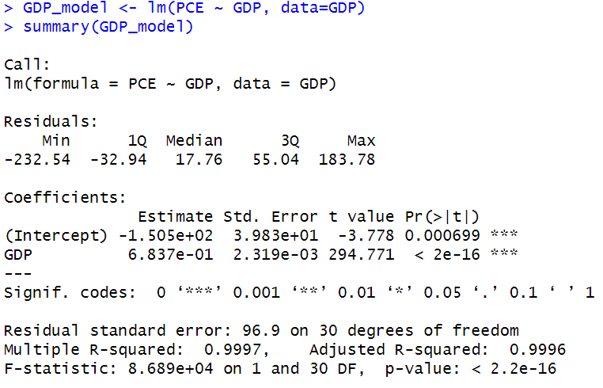
- Df = 32 - 1 = 31
- Critical value = 2.042

Now, since our model was run on our raw data, which consisted of large values for the amounts of dollars. We then decide to run a log-log model, where it takes the natural log of both the dependent and independent variables. This will show how the data grows in percent changes instead of fixed units. This ultimately makes it easier to interpret the data in large numbers. By running this model, notated as Model B, it results in:
- PCE = -0.79 + 1.04GDP
This model tells us that for every 1% increase in GDP, there is a 1.04% increase in PCE, which suggests a very strong positive correlation between the two, similarly to the SLR model.
Model B:
- 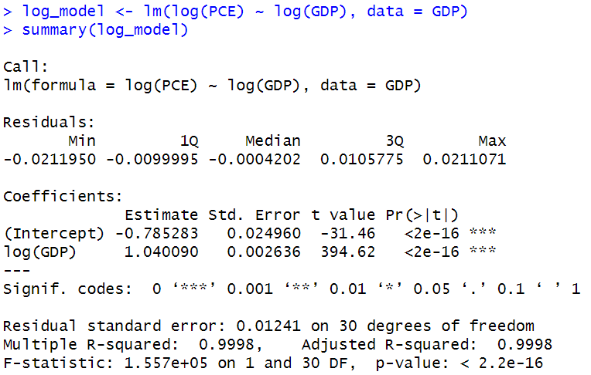
Analysis

When we run both models, we see that there is a high positive correlation between GDP and PCE, which ultimately tells us that as GDP increases in a country, so does overall household spending. To validate our Model A, we can first see that the p-value for GDP is less than 0.05, which tells us that GDP is a significant parameter to estimate spending. Then, we run a t-test using the t-value produced (294.77) and compare it to our critical value with the degrees of freedom of 31 (~30 on the t-table). With a critical value of 2.042, our t-value is much larger, which confirms that GDP is a significant variable. Now, when we look at our coefficient of determination, we can see a very high value of 0.9997 and an adjusted r-squared value of 0.9996, telling us that this model explains around ~99% of the variation in PCE, telling us this is an overall significant model.
However, since we are using a dataset of large numbers which could have a chance of nonlinear properties, to run a log-log model to get a more elasticity interpretation. We see that in our Model B, the GDP t-value and p-value both tell us that GDP is indeed significant like Model A. The only difference is within the r-squared values which results in 0.9998 for both multiple and adjusted. Though both models had similar results and gave us similar interpretations, Model B is overall the better model as the r-squared value is a little higher than Model A’s.
Conclusion
After our OLS models, we can conclude that GDP has a highly positive correlation with PCE. This describes that as the GDP in the US increases, so does the household spending. This could be due to the fact that a higher GDP tells us that more goods are being sold and that there is higher income within the economy, which leads to more people wanting to spend and buy goods. A low GDP would represent a weaker economy, which would align with lower consumptions or spending. With our economic dataset, it is much more accurate to run a log-log model as the raw data includes large numbers of units and may have some nonlinear properties. This produced a more accurate model that explains around ~99% of the variation in PCE by using GDP as the independent variable and gives us an idea of what can affect PCE.

